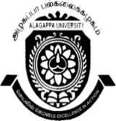
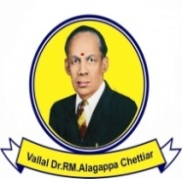
ALAGAPPA UNIVERSITY, KARAIKUDI –630003
(Reaccredited with “A” Grade by NAAC)
DIRECTORATE OF DISTANCE EDUCATION
(Recognized by Distance Education Bureau, (DEB), UGC, New Delhi)

Website:www.alagappauniversity.ac.in Email:dde@alagappauniversity.ac.in
Phone:04565-223420 Fax:04565-225216
Dr. T. R. GURUMOORTHY Date:16.09.2015 DIRECTOR

Sub: DDE - Conduct of P.C.P classes - reg.

*******

The Personal Contact Programme (PCP) of the following course for the Academic Year
2014-2015 will be held as per the following schedule:-

Course: M.Sc., Botany (II Year) (Theory and Practical’s)

Venue | Date | Time
DDE – Science Wing,  6th floor, Room no. 619,  Science Block,  Alagappa university,  Karaikudi – 630 004. | 11.10.2015  To  02.11.2015 | 09.00 A.M  To  06.00 P.M

The Candidates are instructed to check their Name, Enrolment Number and Address given in the envelope with the Identity Card and discrepancies if any, should be reported to the undersigned immediately.

You are also advised to bring your I.D. Card at the time of attending PCP. It is compulsory for the candidates to attend PCP all the days to sit for University examinations. If you do not attend the above practical classes you will have to pay laboratory fee additionally for the next year.

DIRECTOR

Note:

1) Absentee – PCP – Practical Classes : Since you have not attended earlier practical classes, you are directed to pay a sum of Rs. 4000/- (Rupees four thousand only) to be drawn in favour of “The Director, D.D.E, Alagappa University” payable at Karaikudi towards Laboratory fees.

To

Student concerned

